Tuckessee Turners

Woodturners from North Central TN and South-Central Kentucky

We provide an environment for beginning woodturners to get started with minimal start up cost

September 2018 Newsletter

_____________________________________________________________________________________________________________________________

October program

MONDAY MEETING ACTIVITY

In continuation of our demonstration, video, and technique (DVT) series, the meeting on Monday, October 1, 2018, will feature a demonstration by fellow woodturner *David Stricker, member of the Dickson County Woodturners.*

*“I have owned a lathe for a lot longer than I've been a woodturner. I got my first lathe in the 90's. I didn't do much with it. I really got serious about woodturning after I retired in 2007 and moved to east Tennessee. A friend encouraged me to join turning clubs in Knoxville and Crossville and gave me some instruction. I had the time and I had access to free wood so I started turning more. Both clubs had professional demonstrators once or twice a year and I always went to those. I started going to the TAW Symposium in Nashville and saw more good demonstrators. I upgraded my lathe in several steps to a Powermatic 3520B and got better tools. I started taking pieces for the club show-and-tells. I even did demonstrations when they couldn't get anyone else to do it.*

*I guess my signature piece is a square bowls. It got to the point where my fellow club members would comment if I brought in something round. I like to turn green wood. I generally turn green wood to finished thickness and shape. I thought that turning a square bowl would be a challenge and found out that it is and it doesn't matter if it warps a little as it dries. So, I have made a lot of square natural edge bowls. I do turn other things, but square bowls are one of my favorites.”*

*-David Stricker,*

*biography provided by demonstrator*

*Photo credit: Smoky Mountain Woodturners* http://www.smwts.org/Documents/June%20Newsletter%202015.pdf

Please remember, we challenge you to make similar pieces to those demonstrated. At subsequent meetings we ask that you share with the club your turned piece(s), experience(s), and the technique(s) that you may have used or learned. Furthermore, the club would encourage those who have experience in turning these types of pieces to please bring some examples of your work, good or bad, to display Monday night and to offer insight into what you have experienced in regard to the subject. Throughout and at the end of the demonstration you will have an opportunity to have a discussion and question/answer session period to open a dialogue on the subject of the night’s meeting.

The format of DVT has be developed to inspire you as members and our guests to enhance your knowledge about the hobby of woodturning and to challenge you to create. We hope this method of presentation will spur each one of you to try new techniques, as we explore wood-turning through these sessions. A technique session (format to be determined) will be the feature at the November meeting.

- John Duzan, *Vice-President*

Inspirational Links:

How to Make a Square Bowl on the Lathe/Woodturning Project by Carl Jacobson

<https://www.youtube.com/watch?v=CbWpJyt50Mw>

3-Winged Box with Finial by Al Furtado

<https://www.youtube.com/watch?v=JiGGxzCEuWc>

September program

The program was presented by Vice-President John Duzan. He introduced the series on winged bowl turning with a video of Jimmy Clewes turning a Square Oriental Box. <https://www.youtube.com/watch?v=Vmz5BKXBGLA>

2019 Club Membership Dues

Dues for 2019 membership in the Tuckessee Woodturners are due in January 2019. The cost of membership for 2019 is $20.00 per person for the year which can be paid starting at the October 2018 club meeting.

New members who join the club between October 1st and December 31st will only need to pay the 2019 dues and will automatically be member for the rest of 2018 at no additional charge.

A drawing will be held at the December club meeting for admission to the Tennessee Association of Woodturners **2019 Woodturning Symposium** to be held January 25th and 26th in Franklin. To participate in this drawing, you must have paid your 2019 dues before the drawing is held. This is a $165 value.

***Club Activities for* 2018…..**

***Monthly Club Meetings - 1st Mondays***

Monday, October 1st

Monday, November 5th

***Monthly Turn-ins - 4th Saturdays***

Saturday, October 27th

Saturday, November 24th

***Tuesday Evening Workshop***

Tuesdays prior to the Sat. turn-ins

Tuesday, October 23rd

Tuesday, November 20th

***Market Place, Clarksville Square***

Oct. 13th

***Show 'n Tell***

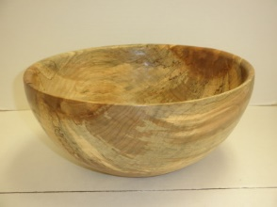

Salad Bowl, Spalted Maple – *Jim Mason*

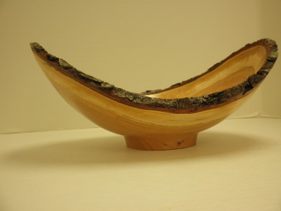

Natural Edge Bowl, Cherry– *Jim Mason*

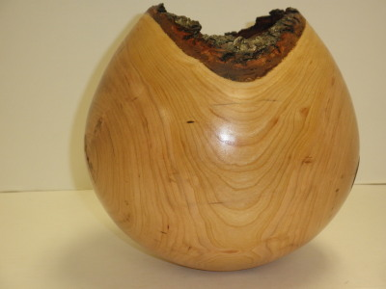

Natural Edge Vase, Cherry – *Jim Mason*

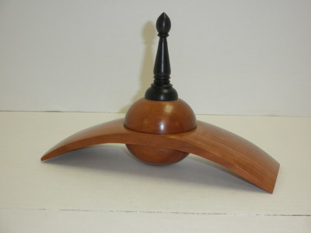

*Box with Finial, Cherry - Jim Mason*

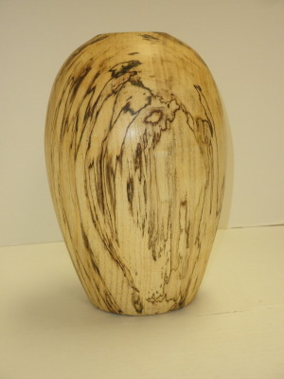

Hollow Vessel, Spalted Hackberry – *Ben Ferguson*

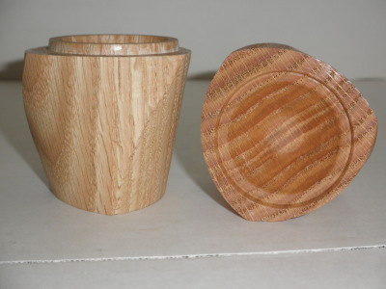

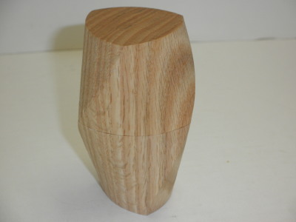

Spiral Box, Oak (from Jason Clark class) –

*Ben Ferguson*

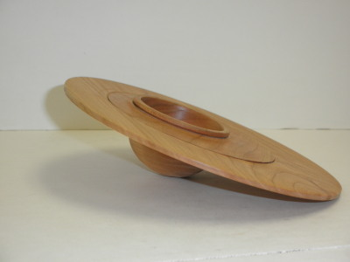

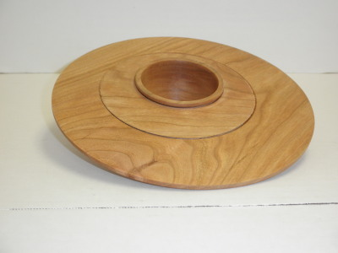

Saturn Bowl, Cherry (from Jason Clark class) –

*Ben Ferguson*

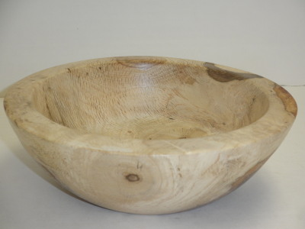

Salad Bowl, Oak Burl – *Max Harris*

**Tuckessee Woodturners**

**September 3, 2018 Club Meeting Minutes**

The September 2018 Tuckessee Woodturners Club Meeting was called to order by President Steve Sabinash at 7:00 pm on Monday September 3rd, 2018 at the FOP Lodge 2576 North Ford Street in Clarksville TN.

Robert Conley was present for the second time as a visitor and joined as a new member.

We are signed up for schedule B at the Clarksville Downtown Market which includes the following dates:

September 15th

September 29th

October 13th

The Vintage Fair is coming up on October 6th at Beech Haven Winery.

We have not received information on signing up for Frolic on Franklin.

Charlie Putnam asked if the club had sent a donation to Paul Ferrell whose shop had been destroyed by fire. Treasurer, Bob Forsythe was not present to confirm whether the payment had been made. President Steve will check.

John Duzan initiated a discussion on what we want to do on Labor Day and Veterans Day when our club meeting date conflicts with the holiday. His suggestion was to have the meeting at a volunteer members home or shop. There seemed to be quite a bit of interest in this with at least one member indicating interest in hosting such an event. As program chair, John will investigate this further.

Charles Wall advised that starting in October he will begin accepting membership renewals for 2019. Dues are $20.00 per person for the year. New members who join between October 1st and December 31st will only need to pay the 2019 dues and will automatically be member for the rest of 2018 at no additional charge. A drawing will be held at the December meeting for admission to the Tennessee Association of Woodturners Conference to be held January 25th and 26th in Franklin. To participate in this drawing, you must have paid your 2019 dues before the drawing is held.

President Steve and several other members described the Tennessee Association of Woodturners symposium that is held each year in January for those who were not familiar with the event. Members were reminded to register early if you wish to attend as the facility can only support a limited number of attendees. The event was sold out last year.

President Steve has some White Oak available. If you would like some, please contact him.

Drawings were held for five Craft Supply gift certificates. They were won by: Ben Ferguson, John Duzan, John Hilborn, Matthew Bashore, and Charles Wall.

Each meeting, members bring in projects they have been working on and show them during “Show & Tell”. Items displayed this month included:

Jim Mason - Sugar Maple Bowl.

Deep Live Edge Cherry Bowl.

Samurai Box (Winged Piece).

Ben Ferguson - Spalted Hackberry Vase (Hollow Form).

Spiral Box (from the Jason Clark class he attended in Nashville).

Saturn Bowl.

Max Harris - Oak Bowl made from a 100 year old tree that was in a lady’s yard in Cooper Town. Max is also making a Dough Bowl from the same tree for the lady’s sister.

John Duzan asked the club members to be thinking about what we would like to do for the December club meeting. We have typically had a business meeting with pizza, soft drinks, and cookies with no program.

President Steve announced that next month’s program would be presented by Dave Strickler

from the Dickson club. It will be a follow-up to tonight’s program as part of the 3-month program rotation Vice President John is trying.

The program was presented by John Duzan who showed us a video done by Jimmy Clews demonstrating how he makes an oriental winged bowl. This will be the first in a series of three themed programs.

Thanks John for an interesting and informative presentation!

The meeting was adjourned at 8:45 pm.

Charles B. Wall

Secretary

**Woodturning Clubs of Interest…**

**American Association of Woodturners**

[www.woodturner.org](http://www.woodturner.org)

**Tennessee Association of Woodturners**

Nashville, TN

[www.tnwoodturners.org](http://www.tnwoodturners.org)

**Duck River Woodturners Club,**

**Columbia, TN**

[www.duckriverwoodturners.com](http://www.duckriverwoodturners.com)

**Tri-State Woodturners Club**

**Chattanooga, TN**

[www.tristatewoodturners.com](http://www.tristatewoodturners.com)

**Blue Grass Area Woodturners**

**Lexington, KY** [www.bluegrassareawoodturners.org](http://www.bluegrassareawoodturners.org)

**Louisville Area Woodturners**

**Louisville, KY** [www.louisvilleareawoodturners.org](http://www.louisvilleareawoodturners.org)

**Cumberland Woodturners**

<https://www.cumberlandwoodturners.com/>

**Crossville, TN** [www.cumberlandwoodturners.com](http://www.cumberlandwoodturners.com)

**Smokey Mountain Woodturners**

**Knoxville, TN** smokeymountainwoodturners.org

**West Tennessee Woodturners**

**Jackson, TN**

[www.tristatewoodturners.com](http://www.tristatewoodturners.com)

**Tuckessee Woodturners**

**Board Officers, Directors & Chairmen**

**President**  – Steve Sabinash

931 221 0603

[ssabinash@gmail.com](mailto:ssabinash@gmail.com)

**Vice President** – John Duzan

931 624 1157

[suprnova001@gmail.com](mailto:suprnova001@gmail.com)

**Secretary**  - Charles Wall

931 624 3716

[wallc@apsu.edu](mailto:wallc@apsu.edu)

**Treasurer**  - Bob Forsythe

031 241 0342

rmforsythe@charter.net

**Editor and Website -** Ben Ferguson

970 219 3983

[benjamin@fergusongis.com](mailto:benjamin@fergusongis.com)

**Our Club Website**

<http://www.tuckessee.org>

**Our Location**

2576 N. Ford Street (New Providence)

Clarksville, TN 37040

**Directions to Club Meeting Place**

***FROM THE SOUTH:*** Take N. 2nd Street north onto Hwy 41A (Providence Blvd), Turn Right on Market St, Turn Right on Chapel St, Turn Left on North Ford St. About ½ mi. rd turns hard right, continue about ½ mile to the last building on the Left. (F.O.P. Lodge)

***FROM THE NORTH***: From Hwy 41A (Providence Blvd) turn left on Chapel St About ¼ mi. turn left on North Ford St. About ½ mi. rd turns hard right, continue about ½ mile to the last building on the Left. (F.O.P. Lodge)

Regardless of which route you take you will think you are lost before you arrive.