Tuckessee Turners

Woodturners from North Central TN and South Central Kentucky

We provide an environment to help beginning woodturners get started with minimal start up cost
April 2015 Newsletter

Presidents Message… Not much new since last month except the weather is finally getting better and with that we start a new season at the market place in Clarksville. See Schedule at the right.
Our next meeting is the 4th of May. Hope to see you all there.
Jon Haig 931 647 3328 jonbh@charter.net
PS. Bring something for Show ‘n Tell.

Max Harris…
May 4th Demonstrator

Max will turn a lidded box. His demonstrations are always fun and educational. You don’t want to miss this one.

In April…
We had Business Meeting instead of a Demonstration

Steve Sabinash, V. Pres and Program Chairman, asked for suggestion about what kind of demonstrators we wanted. Some suggestions were Coloring, Spindle Turning, Ornaments, Safety Class, and a Forrester.

Lathes…

At the April meeting we sold both small lathes to members for $200.00 each. We also purchased a newer Jet lathe from member Jim Mason for $600.00

Club Activities for 2015…..

Monthly Club Meetings
First Mondays
Monday, May 4th Max Harris

Monthly Turn-ins
Fourth Saturdays
Saturday, May 25th Turn-in

Market Place
Saturday, May 16th 1st Group - Jon Haigh
Saturday, May 23rd 2nd Group – Steve Sab.

Saturday, June 6th 1st Group – Jon Haigh
Saturday, June 20th 2nd Group – Sabinash

Saturday, July 4th 1st Group – Jon Haigh
Saturday, July 18th 2nd Group – Steve

April Visitor
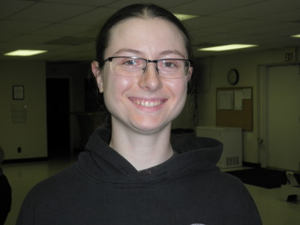
Ashley Marino, 230 Kirby Drive, Clarksville, TN 37042, 636 295 1929, ashleyreed1991@yahoo.com

Show ‘n Tell

Mike Patrick
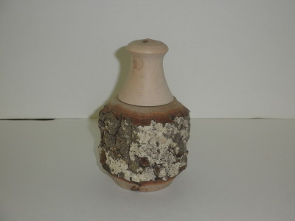
Natural Edge Box with Screw-on Lid

Mike Patrick
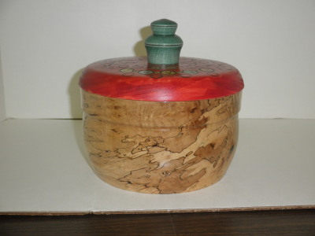
Beads of Courage Container

Jon Haigh
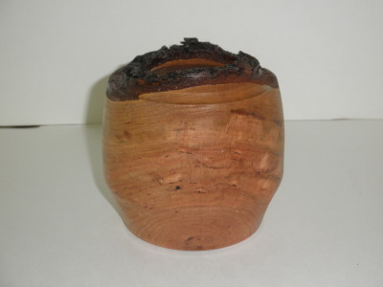
Cherry Hollow Form

Jim Mason
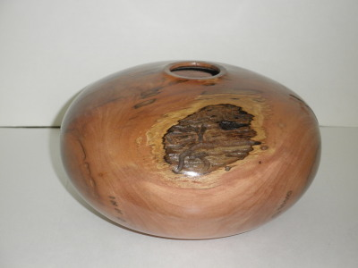
Dogwood Hollow Form 3/16th inch wall thickness

Jim Mason
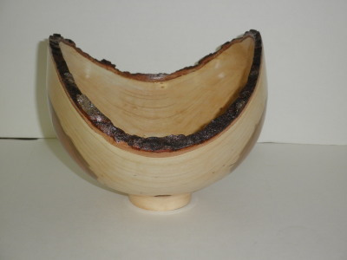
Cherry Natural Edge Bowl

Jim Mason
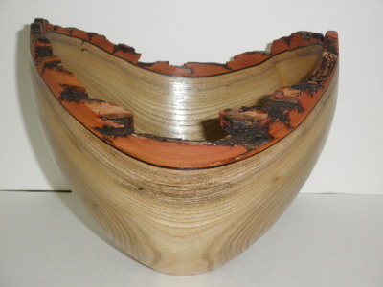
Natural Edge Sassafras Bowl

Max Harris
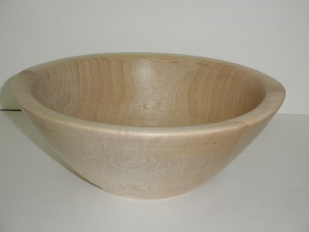
Maple Salad Bowl

Max Harris
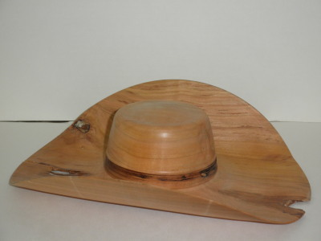
Cherry Hat, the one he demonstrated at our meeting

Max Harris
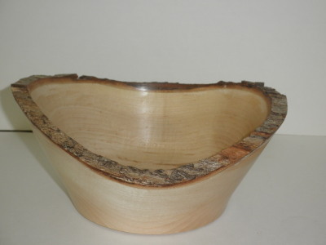
Natural Edge Maple Bowl

Grant Patterson
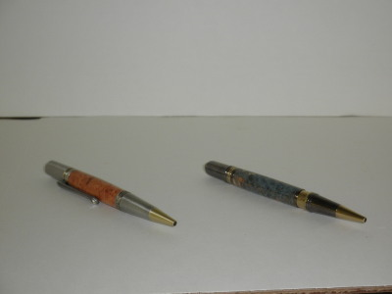
Black Cherry Burl and Blue Maple Burl pens

Steve Sabinash
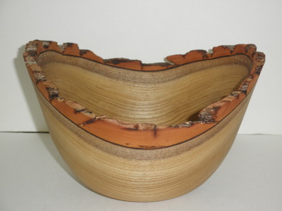
Natural Edge Sassafras bowl

Steve Sabinash
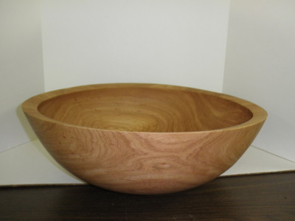
Large Pecan Salad Bowl

Steve Sabinash
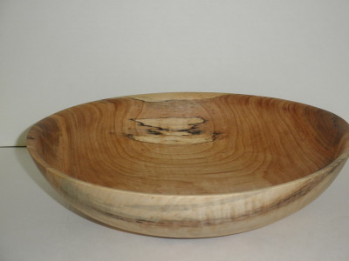
Spalted Pecan Salad Bowl

Mike Canfield
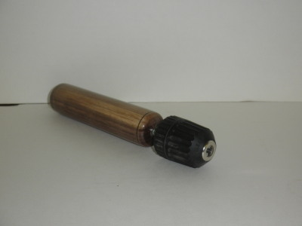
Drill Chuck and Handle

Mike Canfield
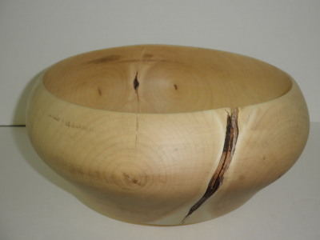
Maple Salad Bowl

Mike Canfield
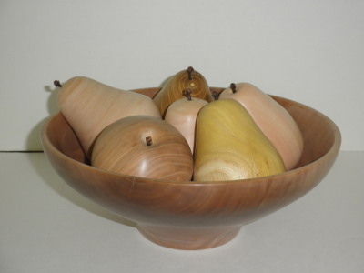
Cherry Bowl with Fruit

Mike Canfield
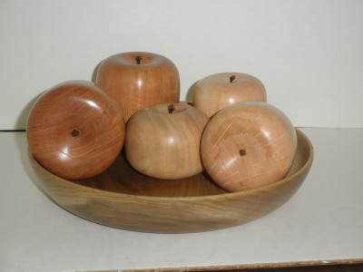
Bowl with Fruit

Unidentified Turner
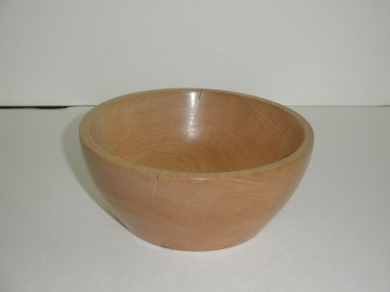

Jeremy Daley
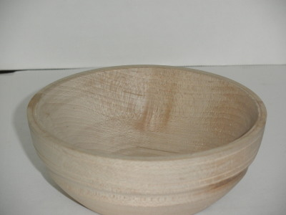
Maple Salad Bowl

Jeremy Daley
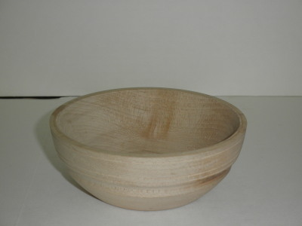
Maple Salad Bowl

Mike Canfield
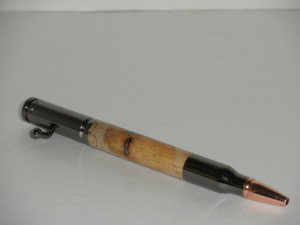
Gun Metal Bullet Pen

Humor for Lexophiles

Time flies like an arrow; fruit flies like a banana.

A backward poet writes in verse.

In a democracy it’s your vote that counts; in feudalism, it’s your Count that votes.

A chicken crossing the road is poultry in motion.

If you don’t pay your exorcist you can get repossessed.

With her marriage, she got a new name and a dress.

A grenade fell onto a kitchen floor in France, resulting in Linoleum Blownapart.

You are stuck with your debt if you can’t budge it.

He broke into song because he couldn’t find the key.

A calendar’s days are numbered.

A lot of money is tainted: ‘Taint yours and ‘taint mine.

A boiled egg is hard to beat.

He had a photographic memory which was never developed.

A plateau, is a high form of flattery.

Those who get too big for their britches will be exposed in the end.

When you’ve see one shopping center you’ve seen a mall.

If you jump off a Paris bridge, you are in Seine.

When she saw her first strands of gray hair, she thought she’d dye.

Bakers trade bread recipes on a knead to know basis.

Santa’s helpers are subordinate clauses.

Marathon runners with bad footwear suffer the agony in defeat.

Woodturning Clubs of Interest…

American Association of Woodturners
www.woodturner.org

Tennessee Association of Woodturners
Nashville, TN www.tnwoodturners.org

Duck River Woodturners Club,
Columbia, TN www.duckriverwoodturners.com

Tri-State Woodturners Club
Chattanooga, TN www.tristatewoodturners.org

Blue Grass Area Woodturners
Lexington, KY bluegrassareawoodturners.org

Louisville Area Woodturners
Louisville, KY louisvilleareawoodturners.org

Cumberland Woodturners
Crossville, TN cumberlandwoodturners.com

Smokey Mountain Woodturners
Knoxville, TN smokeymountainwoodturners.org

West Tennessee Woodturners
Jackson, TN tristatewoodturners.com

Tuckessee Woodturners
Board Officers, Directors & Chairmen

President - Jon Haigh 931 647 3328 or
jonbh@charter.net

Vice President – Steve Sabinash 931 221 0603
ssabinash@gmail.com

Secretary - Charles Wall 931 624 3716
wallc@apsu.edu

Treasurer - Bruce Hensley- 931 553 8198
hensley144@hotmail.com

Social and Publicity Secretary
Charles Putnam – 931 362 3669
charlesrjoan@bellsouth.net

Editor - Jim Mason jmason@newwavecomm.net
270 885 0069 (office) 270 484 0571 cell

Our Club Website
www.tuckessee.org

Our Location
2576 N. Ford Street (New Providence)
Clarksville, TN 37040

Contact the Editor
Email – jmason@newwavecomm.net

